SUNSET SERIES
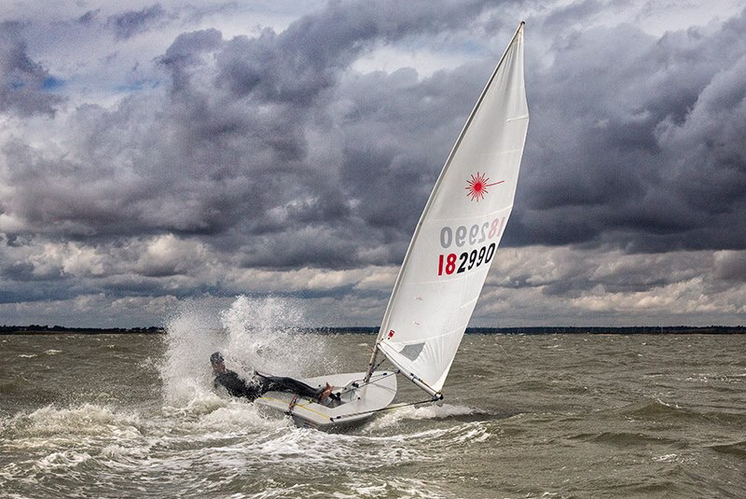

SAFETY PLAN
2024

N

PHILOSOPHY

The Sunset Series is a Racing and training event organised by the Sunset Committee of the Dabchicks Sailing Club through its official Terms of Reference. The event is usually sailed on Summer Monday and Wednesday evenings as per the sailing programme but may be sailed on other days and at other times.
The Sunset Committee has delegated the operational aspects of on water safety to the Sunset Series Safety Officer (or their nominated deputy for each session) who is responsible for all operational and related preparatory aspects of safety for the session.
For the avoidance of doubt the Sunset Series Safety Officer together with the Race Officer and fleet coaches are the final authority in deciding whether the training or racing shall take place. It may be on certain occasions fleets are released to sail but not race depending on ability. This decision will be made by the Safety Officer.
The Safety Officer’s decision is final as to who/what is within his safety team of volunteers and who/what is not. The nature of the event is that of a training and racing evening. Sailing will take place in a variety of venues within the Blackwater estuary and its creeks. On no occasion will sailing take place further West than the Thirslet Buoy or further East than a North/South Line 1.5 miles East of the Nass beacon

DEFINITIONS
Safety Boat

A Safety Boat is any vessel with the following characteristics:
- Capable of speeds in excess of 15 mph
- Capable of carrying at least two people
- Capable of operating in a Force 5 wind at the location
- Capable of manoeuvring alongside an Optimist without likelihood of causing material damage
- Capable of staying at the race area for the likely duration of sailing, plus 2 hours
A Safety Boat should have on board a minimum of two persons, both to be 16 or over and one to be an adult, at least one person to the standard shown below:
- Current first aid certificate; and
- RYA Level 2 Powerboat Certificate, or equivalent, or person who has completed the DSC Coxswains course, or has a known track record on the water to the satisfaction of the Safety Officer.
- It should be noted that under DSC insurance conditions only holders of a valid PB2 may drive club ribs.

A safety boat will have the Minimum equipment list as later defined, including a first aid kit and a marine Band radio.

Support Boat.
If a boat and/or crew do not meet the Safety boat standard it will be delegated as Support boat or Coach boat assisting the Fleet leaders. Support boat drivers must be competent in boat handling and have ideally completed the Dabchicks Coxswain course. Non-Dabchicks boats must have an extension to their insurance policy confirming use as a Support Boat.

SAFETY / SUPPORT BOAT TO DINGHY RATIO
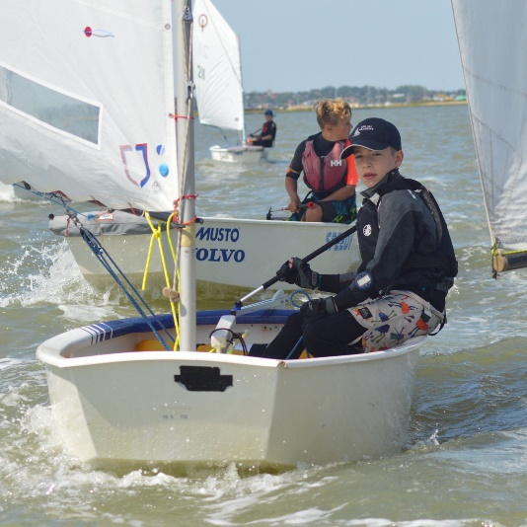
There should always be one Safety Boat per fleet plus additional Safety / Support boats as required. Prior to sailing each week the safety officer will conduct a dynamic risk assessment with the Instructors and Safety Boat team and assess whether there will be sailing for that individual fleet. This assessment will include
- Number of available boats
- Competency of vessels
- Number of sailors
- Competency of sailors
- Prevailing weather and tide conditions
This may result in some fleets sailing and some remaining ashore, moving support/safety boats between fleets and any other results. The decision of the safety officer together with the Instructors and/or race officer is final.
It should be noted that there may be occasions where the Race Officer may decide that there is too much wind for racing, but the Safety Officer allows limited sailing with sufficient safety cover for more experienced sailors.

SAFETY BRIEFING FOR SUNSET SERIES
The Safety Officer will hold a general briefing for all safety and support personnel prior to the Sunset series. This date and time and location, (which may be virtual/online), will be published at the New Season Briefing Evening usually held in April.
The DSC will also hold at least once per year a training programme (Coxswains course) where personnel will be taught how to handle and use Club safety Equipment.

Each week a roll call of available boats will be made prior to the decision to launch.

The general safety Briefing and the coxswains course will cover at least the following items;

- The safety of people will always have priority over equipment.
- There is the additional duty of care for parents and the Event Team associated with working with young people so higher levels of vigilance are required.
- The Beach may be wet and slippery and has a variety of trip hazards care should be taken. Areas extending from the beach in all directions have very soft mud and suitable clothing and footwear should be worn. The beach area is defined as all launching, recovery and transporting boats from the water to their normal parking area

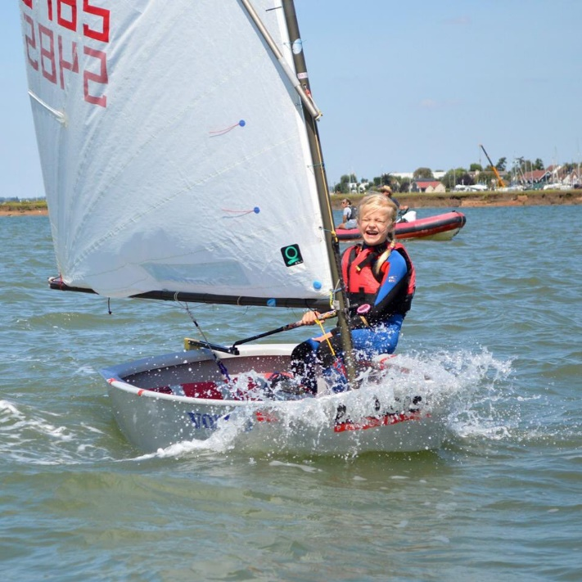
- All support and safety boat personnel will wear buoyancy aids and kill cords at all times while on the water and on the pontoons. Failure to do this will result in dismissal from the event. All competitors will wear buoyancy aids when on the beach area. Dry suits and wet-suits are not adequate buoyancy.
- All support and safety boat personnel will keep a good look out at all times for dinghies in trouble and other vessels.
- All competitors will comply with the requirement that suitable clothing is worn when on the water.
- Safety Boat crews and Support boat crews do not have to wear dry suits or wetsuits and may wear appropriate clothing for their duties. At least one Safety Boat crew member shall be kitted out suitably so as to be able to enter the water to conduct safety duties.
- The expected level of sailing competence for this event is wide ranging from competent, to beginner.
- The Safety Boat /Support boat driver decides if he/she feels comfortable to provide safety cover in the prevailing and/or anticipated weather conditions. It is then quite simple – Inadequate safety cover means No sailing! The Safety Officer will make this call but also relies on members of the safety team to inform him of their own comfort in the prevailing or anticipated conditions.
- For each Fleet there will be nominated safety or support boats who will work with the respective Fleet, the Race Officer, and the Safety Officer. They are responsible to the Safety Officer. The Fleet Leaders will operate from their own Support/Safety Boats and will ensure the smooth local operation of the training and safety. These boats will oversee the support cover on their own courses under the control of the fleet leader.
- Please keep your speed and wash to a minimum
- Medical details for their fleet will be held by the fleet leader, safety officer/control, chair, sunset admin and the beach master. Medical details are held in confidence and not to be displayed or distributed and should not be left lying around. All copies are to be destroyed at the end of the season. An electronic copy will be held by DSC in accordance with the need to keep records and the Data Protection Act.
- All fleet leaders are to ensure that they are first aid qualified and that their qualification is current. Failing this it must be ensured that there is someone with a suitable first aid qualification in the coaching team for that fleet and that they are afloat with the fleet
- Drinking alcohol when on safety or support boats, or when preparing to go on the water, is not allowed at any time.

SAFEGUARDING & IDENTIFICATION LANYARDS
- Identifying Lanyards will be issued for each session to all participating volunteers who are on the official Sunset Rota for that session. For example, Beach, Safety, and Galley. These will be issued by the appropriate team leader. All Lanyards must be returned to the leader at the end of the session.
- If you are out on the water, or in the galley, parents must make their own arrangements for other responsible adults to look out for their child.
- All parents not volunteering on beach shall advise the Beachmaster who the responsible adult is for their child, and they will keep a simple list.
- It is the parents responsibility to advise their child on who their chosen responsible adult is.
- Parents/responsible adults not on a rota should remain available as always at immediate notice in the vicinity of the Beach.
- People who are not volunteers and not parents should be asked by the collective to remain a reasonable distance from the young people.
The purpose of the identifying lanyards is to enable everyone participating to readily know who is and is not formally part of the Sunset volunteering team. Where Sunset volunteers or participants see a person without a Sunset lanyard attempting to assist on Sunset, either on the water or onshore, that person must be immediately and respectfully asked to refrain from trying to assist and to keep their distance. Any person who wishes to assist on Sunset who is not included on the Sunset Rota for the session must not be given a Sunset lanyard without the approval of the Sunset Chair or the Sunset Safety Officer.

EQUIPMENT
Safety Boats will comply with these minimum equipment levels, it is advised that Support Boats carry them:
- First Aid kits
- Knife and pliers/wire cutters
- Two 15 meter tow ropes
- VHF Radio (If a support boat does not have a VHF Radio then a basic form of hand signal communication must be agreed with the Fleet Leader. The Fleet Leader must carry a VHF Radio)

PRIORITIES FOR BEACH LAYOUT & USAGE
The beach will need assertive management – the Beachmaster will handle this and the Beach team are considered part of the safety team. No boat or fleet may launch without the permission of the Beachmaster. Permission to launch fleets may only be given by the Safety officer when he is satisfied that all rescue facilities are in place. The launch will then be coordinated by the Fleet Leader.
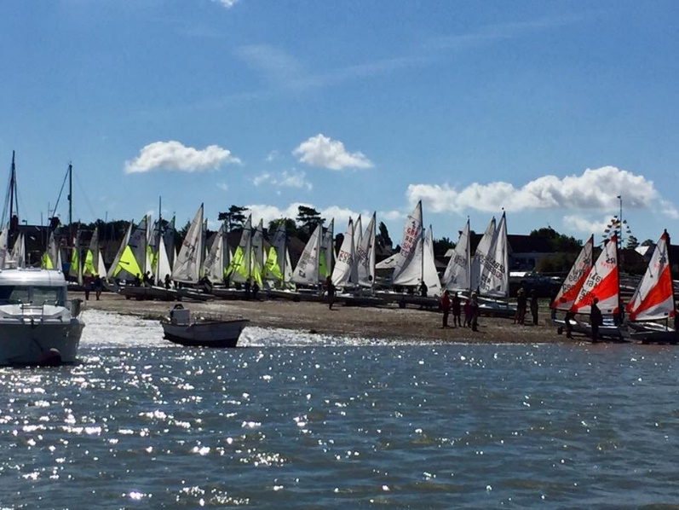
All participants MUST tally before going on the water. Participants must untally before they leave the Beach, failure to do so will lead to disqualification. The Beachmaster and assistants should endeavour to ensure that all buoyancy aids are on and fitted correctly, the boats are seaworthy and suitable clothing is being worn.
The Hammer head will be busy and is not for the exclusive use of Safety and Support boats.

TIMINGS
Safety officer, Race officer and Instructors will meet at approx. 1800hrs, to assess the weather and the evening plan.

COMMUNICATIONS
VHF Radio Channels:
All Fleets Safety: Marine Band Channel 37a. Sometimes known as M or M1
Safety Incident channel: Marine Band Channel 77
All Safety and Committee Boats will monitor their assigned frequency and should not use others. Please keep traffic to a minimum and listen to the channel before broadcasting. No boat should use the channel scanning functions whilst involved with this event. Experience has shown that you will be on the wrong channel when we need to talk to you! Please remember that communications make or break an event; thus please remember to use proper voice procedure, Over when you mean it and Out when you have finished.
If you are within close proximity, a face-to-face conversation is always preferable. Normal voice procedure is required, call signs will be listed in a separate sheet. The Event Safety Officer in consultation with the Race Officer will instigate ALL OUTSIDE COMUNICATION.
Mobile phones may be used by Race Management to minimise radio traffic when passing results information to shore. This will seem very rigid, but we have learnt it is necessary for the smooth running of a large event.

TOWING
If possible, all towing should be avoided since with so many moorings it is a difficult operation. Instruction to tow can only be given by the Fleet leader in conjunction with the Event safety officer and Beachmaster. The rules below are mainly for the junior fleets but the principles may be used for most boats. Skiffs are different and only experienced people in Ribs should undertake this duty
To avoid confusion the rules for optimists are as follows:

Tow Pick up
- There should be in all cases be 2 persons on the tug.
- The beach will prepare the boats as follows:
  - Launch the boat and ties a loop at an appropriate point (1.5 to 2 boat lengths from the bow) in the painter
  - Starting from the back of the tow pass the painter of the boat in front through the loop of the one at the back (daisy chain)
  - Ideally connect a maximum of 4 in a single daisy-chain
  - Unclip the mainsheets
  - Remove the dagger boards
  - Advise the sailors to sit down in the boat and to steer around obstacles and follow the boat in front.
- One person in the water should hold the painter of the first boat ready for the tug.
- Tug collects the first painter and quickly makes it fast to a strong point on the boat.
- One person on the tug watches behind and the tug moves off slowly.
- Make enough speed that the last boat has steerage way. Do not make excessive speed.
- When passing an obstruction please give enough sea room for the tide and wind conditions.

Tow drop off
If practical pick up a mooring, drop an anchor and switch off the engine. If this is not possible then hold the tug head to wind. Try to be up tide or upwind of the committee boat depending on the greatest effect. When the instruction is given to release:
- Ask the children to clip on their mainsheets
- Replace the centreboards
- When everyone has done this start to unchain them starting from the front.
- Take your time
Collecting boats to tow in, is the reverse of coming out, except hold the tow boat head to wind.

Do NOT tie the tows to the toe straps, or wrap it around the tow straps and expect the child to hold on all the way to or from the course area. Avoid asking the children to tie knots (even some adults). All of the above lead to problems.

LAUNCHING
The procedure to launch will be as follows:
- The safety officer will check with the fleet leaders or Race officer that they are ready to receive the boats and there is likely to be an event
- The safety officer will check with the Beachmaster that the fleets are briefed, tallied and ready to launch.
- When satisfied that all is ready the safety officer will pass control of each fleet to the respective Fleet Leader who will direct the support boats into position
- The Safety Officer will issue the instruction to the Beachmaster to launch

SPECIFIC ACTIONS

Procedure to get boats to the saling area:
Hold the boats in separate fleets and then proceed as a controlled bunch with Support/Safety Boats spread throughout the bunch.

Procedure to get boats back to the shore base:
Hold the boats in manageable groups of boats (4-5 boats) and then proceed in groups with a Safety Boat /Support per group. In a particularly safe area and in safe conditions, simply provide safety cover spread-out over the route that the boats sail from the race area
Procedure for retiring Boats:
A Retiring Boat informs a Safety/Support Boat and is directed by that boat to a safe location. The Support/Safety Boat decides whether to remove the sailor from the boat. If the sailor is removed, the boat must be attached to one of the buoys Leave the boat with a plastic tape tied to the pintles. If the sailor needs to receive attention ashore, leave the boat with plastic tape tied to the pintles.
The group is escorted ashore, handed over to the Beachmaster who confirms to Safety Officer that they have been accounted for. If they are not accounted for, the safety Officer will deploy boats to commence a search and if appropriate notify HMCG.

Under no circumstances are boats to proceed ashore unescorted!

CONTINGENCY ACTIONS
The following actions are very important and should they be actioned by the Safety Officer or Race officer please make sure they are clear to you.

FOG

Guidelines for use when fog descends:
If fog arrives prior to the start of the event – The Safety Officer, Fleet Leaders and RO agree to postpone racing and the safety Officer requests the Safety Fleet to implement Fog Guidelines. The fleets are informed by support and safety boats to stay close to the lead boats and to take tows.
If fog arrives during an event – The safety officer, fleet leaders and RO agree to abandon racing and the Safety Officer requests the Safety Fleet to implement Fog Guidelines. Fleets are informed by the safety and support Boats on each leg of the course to stop, stay close together and to take tows.

If the boat cannot see a safety boat, they are to STOP, stay with any other boats that they can see and wait.
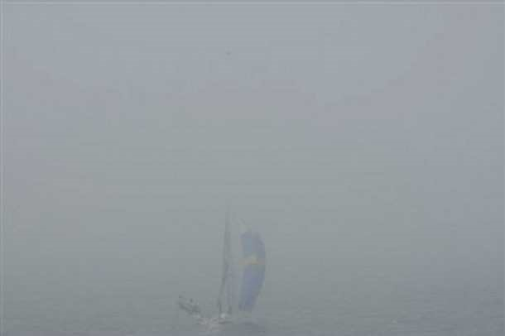
Safety fleets gather boats together and take in tow. Each safety/support boat will need to secure as many boats as they are able. Keep all others in sight. All sail numbers should be recorded on board and passed when requested to the Event Safety Officer, the broadcast will be monitored by the Beachmaster who will also record the numbers against the Tally board. All boats should proceed ashore slowly, collecting other boats as they go. The Beachmaster calculates the total number of boats in tow/escorted and informs the Safety Officer. If the total number does not equal the total of the boats that went afloat, the Safety Officer will instruct for a search to commence and notify HMCG if appropriate.
Boats must be tallied ashore as normal.
Under no circumstances are Boats to proceed ashore unescorted!

STRONG WIND

Guidelines for use when strong winds arrive:
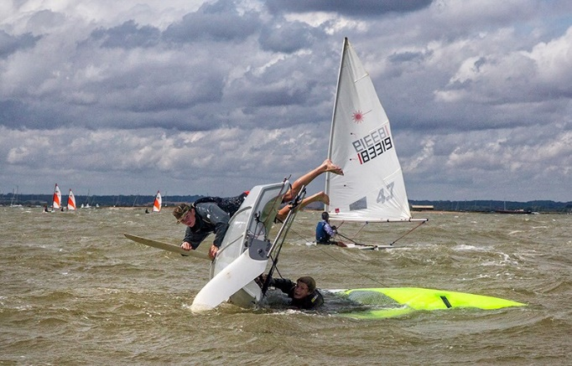
If strong winds arrive during a race – The safety Officer, Fleet leaders and RO agree to abandon racing and the safety Officer requests Safety Fleet to implement Strong Wind Guidelines. The Fleets are informed by the Safety Boats on each leg of the course to stop, stay close together, to stay close to them and to heave to. Safety Fleet gather boats together in groups and once sensible groups are formed, The Safety Officer will request each Support/Safety Boat to get the participants to safely sail to the shore. Each Support/Safety Boat will be asked to escort the participants in a group.
In the event of a capsize, the group should stop until the boat is righted and ready to sail again.

Boats will be tallied ashore as normal.
Under no circumstances are Boats to proceed ashore unescorted!

Approaching a Capsize
ALWAYS, the first priority is the safety of the person(s) in the water. When approaching a capsized dinghy ensure that you can see the sailor(s) who was on board. ‘Count heads’. Approach the dinghy and stand off the capsized boat about by about 2 boat lengths. Generally, when approaching a dinghy and/or a person(s) in the water, the safety boat driver should ensure that the people in the water are as far away from the safety boat propeller as possible.

If you cannot see all of the dinghy crew, you must ensure that no one is trapped under the dinghy but don’t panic if you do not see them straight away, usually they are just out of sight on the far side of the dinghy. Once you are satisfied that the dinghy crew are safe, remain standing-off while they right the boat. Keep a careful watch over less experienced or very young sailors, who may have difficulty getting back on board their boat. If the dinghy crew are unable to right the boat and need help, you should assist as most appropriate for the dinghy type.

Depending on the water temperature, and the quality of the sailors sailing gear, even a fit and healthy person in the water can become very cold and/or exhausted in a short time. You need to make a judgment call on whether they are going to be able to quickly get back aboard or if they are simply going to exhaust themselves. If, in your opinion, they are struggling tell them that you are going to assist.

Bringing Someone On Board
Once it is decided that someone needs to be brought on board, approach as you would for a man overboard and once you are within 2-3 metres switch off the engine. It is vital that you ALWAYS, stop the engine as you close-in on people in the water. When approaching the dinghy, be aware of loose lines or rigging that could foul the propeller. If there is more than one person in the water, decide who to bring aboard first, e.g. if someone appears to be approaching exhaustion get them first.

When you bring someone aboard the safety boat, make sure that they are kept warm. Lend them a sailing jacket or wrap them in a thermal blanket if necessary. If someone is so cold that they need to be kept warm, they should be taken ashore as quickly as possible to be warmed-up. If you think this needs to be done radio the Safety Officer and let them know so that this can be arranged as quickly as possible. In addition, abandoned boats should be identified by tying red/white tape to the rudder pintles. This will inform other safety boats that the boat has been abandoned but with the sailors removed.

EMERGENCY PROCEDURES
The phrase ‘Priority Code Red’ used twice, denotes a situation of a nature critical to the safety of the event and the personnel involved, for example a Medical Emergency, entrapment under a boat, or an incident of similar severity. Upon hearing this phrase ALL radio traffic not involved with this incident will cease on that channel. The sailors not involved will continue as planned with the safety/support under the leadership of the Fleet Leader, they will continue racing or hold in assigned race area inside the cordon of course buoys if not racing and until instructed to proceed to shore.
The Support boats assigned to that fleet will enforce the penning and provide reassurance and comfort!
The Support boat/Safety boat that has the incident will, if possible, isolate the problem from the rest of the fleet and give their location. The Safety Officer and the safety boat nearest (if the reporting boat is not a safety boat) will move to assist. The Safety Officer will then redirect additional resources as necessary. All boats involved in the incident will change channel to 77. The safety officer will notify HMCG and ask them to monitor the safety incident channel.
If a casualty needs evacuation to shore the role will be allocated to a Safety boat as required. If needed additional personnel to assist the casualty will be pulled in from surrounding craft E.g. medical personnel, diver or outside agencies. This will be organised by the Safety Officer. The casualty will be met by the Beach master, shore team and First aiders. When the incident is closed, all boats will return to Marine Channel 37 safety channel and the safety Officer will advise the Fleet Leader.
Individual vessels will not be towed back to the beach, unless so instructed by the Fleet Leader.
If a dinghy is abandoned a marker tape is to be tied to the rudder pintles and the Safety Officer is to be informed. If possible, dinghies should be tied together and to one or more of the various buoys provided that time permits – personnel safety always takes priority. Retiring boats will have their details passed to the respective Fleet Leader or RO Leader and will be penned together in a safe place until there are enough boats to send home safely under the supervision of a Support Boat as directed by the Safety Leader.

END OF DAY
Stand down when told by Safety Leader, this will be gradual as the fleets progressively come ashore. The Fleets will not be dismissed until all boats on shore and sweeps done to confirm this. Please do not disappear until you are instructed.

FIRST AID
All Safety Boats will have trained first aiders, all Safety Boats shall carry first aid kits.
Each fleet will have a trained first aider in a support boat.

ADDITIONAL SAFETY CONSIDERATIONS

Diamond, Emerald and Bronze fleets must be inspected before participating in the Sunset Series. These inspections are intended specifically to support effective running of these particular Optimist Fleets and they do not provide assurance that boats are seaworthy.

SUPPLEMENTARY DOCUMENTS

1. Child Protection Policy a copy of which is available in the Club Race Box
2. Emergency Incident Plan, a copy of which is available in the Club Race Box
3. Club Coxswain Course held annually to train Safety/Support Boat Drivers.
Details on the Club Web page

Diamond Lake Sessions.

Diamond Fleet will be doing various early season sessions on Mersea Boating Lake. The following additional points apply in respect of those sessions:
- The number of optimist sailing dinghies on the lake will not exceed 18 at any one time.
- Children will wear buoyancy aids at all times when lakeside and afloat.
- Instructors and parent helpers will wear buoyancy aids when lakeside or afloat.
- Children will be registered upon arrival/departure.
- Rescue/support to be carried out in mixture of rowing/sailing dinghies, kayaks and paddle boards.
- Radios or walkie talkies will be used by instructors to communicate where required.
- A nominated Session safety officer (acting as nominated deputy to the Sunset Safety Officer) with the Instructors will assess and monitor weather conditions before and during the day and act accordingly. This may include reefing when appropriate, reducing numbers on the water and suspending or cancelling the sailing as necessary.
- Instructor/sailor ratio of at least 1:6 will be maintained at all times.
- Instructors will be responsible for their pod of 6 sailors. At least one responsible parent must remain on site and will be responsible for their child except during snacks, toilet breaks and lunch.
- Children will not be allowed to swim or jump in the water unless permission is given by the instructor.
- Detailed medical information including swimming ability to be held by instructors.
- Qualified first aiders will be on site (Sunset instructors and Lake staff). First aid kit to be held at a central point.
- The session safety officer will ideally not be instructing but overseeing safety.

